31st October, 2023
RE: CREATION OF 25 NEW CONSTITUENCIES
The attention of the Electoral Commission has been drawn to a statement in the media to the effect that 25 New Constituencies are going to be created ahead of the 2024 General Elections.
The Commission wishes to state for the information of the General Public that it is only creating One Constituency, which is the Guan Constituency in the Oti Region. The Commission has not taken any decision on creating constituencies beyond that of the Guan.
We urge the General Public to disregard this statement.
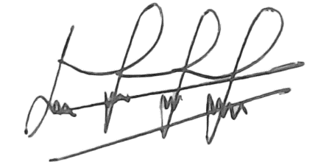
MICHAEL BOADU
AG. HEAD, PUBLIC AFFAIRS

