9th December 2024

# SPEECH DELIVERED BY MRS JEAN MENSA, CHAIRPERSON OF THE ELECTORAL

**COMMISSION OF GHANA, AT THE DECLARATION OF THE 2024 PRESIDENTIAL ELECTION RESULTS.**

A good evening to you all. To GOD be the glory, great things He has done and greater things He will do. We thank the good LORD for making it possible for us to witness this day. Ladies and Gentlemen, it has been 48 hours since the clos polls closed.

The Voters of Ghana have spoken. They have expressed their choice at the Polls, and that choice will today be upheld by the Electoral Commission. As a Commission, we have fulfilled our avowed aspiration to imbibe transparency, accountability, inclusiveness and responsiveness at the heart of all our operations. And I can confidently say that with the help of God, we have fulfilled our aspirations and the expectations of the citizenry. We have conducted elections that are credible, fair, transparent and peaceful; Elections that have upheld the will of the people as expressed at the polls; Elections that have guaranteed that every vote counts.

As a country, we should take pride in the fact that our electoral processes initiated since 1992, uphold and guarantee that the voters choice as expressed at the polls is sacrosanct.

Ladies and gentlemen, the last four years have been spent injecting and infusing four (4) key elements. Transparency, accountability, responsiveness and inclusiveness in all our operations. As such, we started the year poised and ready to conduct credible elections and were conscious of the fact that elections are not an event but a process.

This resolve led us to take several transformational decisions including re-exhibiting the Provisional Voters Register (PVR) for the first time in our history when concerns were raised about its credibility, as well as opening up the IPAC meeting to the citizens by allowing the live coverage of all IPAC meetings.

Indeed, the decisions to re-exhibit the PVR to allow a further review by the political parties and the citizenry, as well as the demystification of the IPAC meeting helped in diffusing the tensions over the Provisional Voters Register. Ultimately, it restored confidence in the Voters Register and cemented Ghana’s peace.

Again, in the spirit of responsiveness, when complaints were made about the 50 pesewas charged voters for the verification of their registration details online, the Commission waived the fee and allowed voters to verify their details at no cost.

In line with our determination to ensure the credibility of the 2024 Elections, when the Commission was informed of the leak of a single defaced ballot, the Commission acted swiftly and destroyed ballots for both the Western and Eastern Regions. This bold decision was based on our determination to uphold the integrity of the Election at all cost. In less than one week, the Commission printed new ballot papers for both regions and went on to successfully hold the Special Voting, two days ahead of the main election.

As a Commission, our singular message to our teams at all levels has been clear - it is our mandate is not to make anyone a President or Member of Parliament. But rather to conduct and undertake credible & transparent elections and electoral processes which uphold the voters choice and lead to acceptable and peaceful elections

Today our resolve has paid off. We have conducted

1. Elections that are free,
2. Elections that are fair
3. Elections that are credible
4. Elections that are transparent
5. Elections that are peaceful and
6. Elections whose outcomes are acceptable by all.

So transparent are our processes that any interested Political Party, media house or citizen can collate with near precision the results of the election, attesting to the resilient and robust processes built over the years. And we witnessed this with the concession of the Vice President, even before the declaration of results by the Electoral Commission.

Many citizens have attested to the seamless processes that they witnessed at the Polling Stations. The average time spent at the Polling Station was 5 minutes compared to several hours spent at the Polling Station prior to the 2020 election.

Citizens have also attested to the efficiency of the BVDs employed to ensure that each man has one vote – the system worked efficiently and ensured that the voter who registered was indeed the person who voted.

As the commission we are confident that the 2024 Election will further cement trust in our electoral process and reduce the suspicions that typically characterise Elections on the continent.

At this juncture we would like to thank all who have journeyed with us to ensure the success of the 2024 Election.

To our staff, both permanent and temporary — we say Ayekoo. You have worked hard, put in long hours, ploughed the fields and done the spadework, at the risk of your own lives, to bring us to a successful end. Our hearts go out to our staff who were manhandled during this time. May God bless you all.

To our media partners who have walked this journey with us and enabled us to bring the Commission to the doorstep of every Ghanaian, we say thank you.

To the Ghana Police Police Service and the National Peace Council, thank you. We say thank you to the good citizens of Ghana; you have believed in us and allowed us to serve you.

To our dear families and friends, you have journeyed with us every step of the way. We thank you for your support, your prayers, your advice and your encouragement.

We are conscious that we could not have achieved this success without the help of the Almighty God our anchor, without whom we can do nothing. We remain eternally grateful. Thank you JESUS.

And to all our observers; ECOWAS, AU,

ECONEC, The Commonwealth Secretariat, West Africa Elders Forum, National Peace Council,

CODEO, AAEA, ECES, IDEA, IEA, Frempong Manso Institute, IDEG, and to all Commissioners of the Electoral Management Bodies in Africa - Uganda, Gambia, Kenya and Liberia we say thank you for your support. We wish you Godspeed back home.

As the Returning Officer for the Presidential Election and in fulfilment of my mandate as enshrined in Law, I will now declare the outcome of the 2024 Elections. It is important to note, that per Regulation 63(3) of the 1992 Constitution of Ghana, the winner of a Presidential Election must obtain at least 50% + 1 at the Polls to be declared the winner of an Election.

We have collated the Presidential Results from all the 16 administrative regions – of which 267 of the 276 Constituencies have been captured. We have not been able to receive results from nine constituencies because our offices have been besieged by political party supporters, making it impossible to complete the collation process. That notwithstanding the Presidential results from the 267 constituencies including the Guan

Constituency, clearly establish the winner of the 2024 Presidential Election. Simply put, even if all the votes from the nine constituencies are added to the Candidate who placed second, it will not change the outcome of the election.

The Commission will update the records on receipt of the Presidential results from the outstanding nine Constituencies.

Now to the Presidential Results. This will be announced based on the positions of Presidential candidates on the ballot.

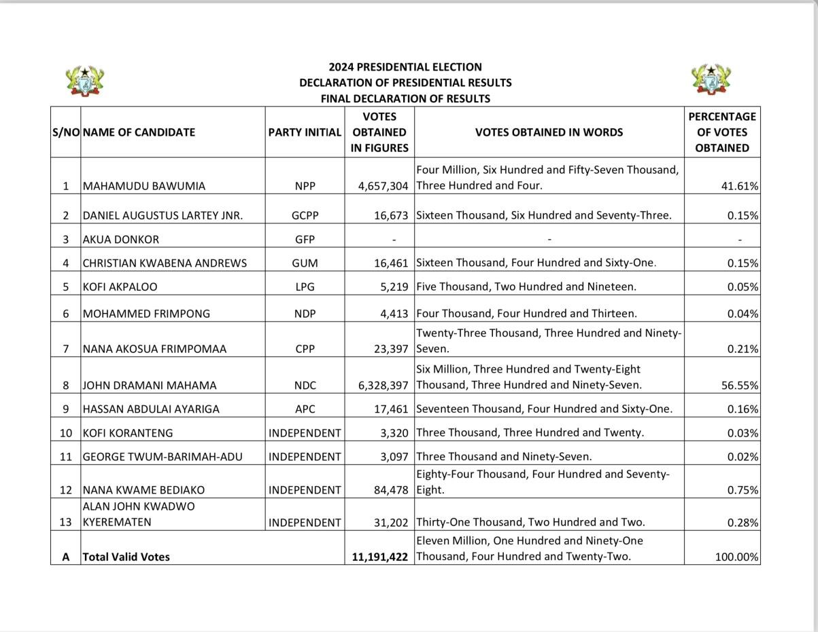

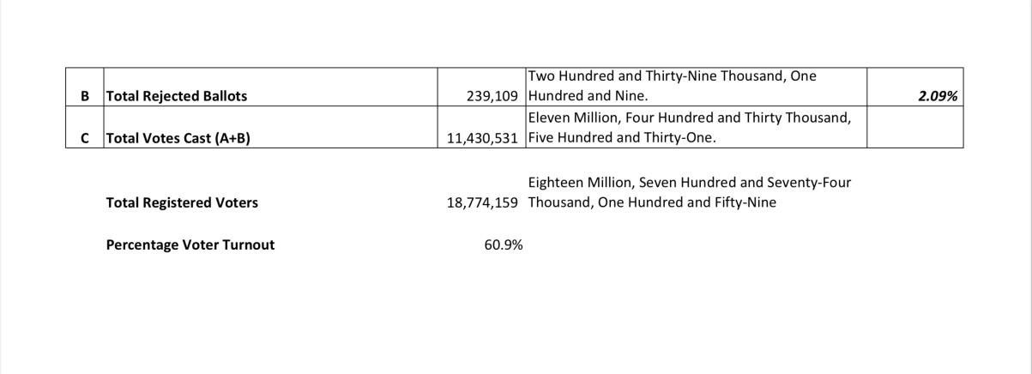

As mentioned earlier, results from the nine constituencies are still outstanding. They are:

1. Awutu Senya East,
2. Nsawam/Adoagyiri,
3. Akwatia,
4. Suhum,
5. Techiman South,
6. Dome Kwabenya,
7. Ablekuma North, 8. Ahafo Ano North,

9. Damango.

Total Registered voters in all nine constituencies amount to 947,116.

In the event that all the valid voters from the nine constituencies above, voted for the candidate who placed second, the total number of votes he would garner would be 5,604,420, representing 46.17% of the total valid votes which would have been 12,138,538. The inclusion of the outstanding Constituencies would have given the leading candidate 52.13%, which is still higher than the 50% +1 and therefore still makes him the winner.

In light of the above, I have the honor as the Returning Officer of the 2024 Presidential Election, to declare H.E John Dramani Mahama as the winner of the 2024 Presidential Election and the President Elect of the Republic of Ghana - with a total percentage of 56.55%. Congratulations Sir. It Is Finished!