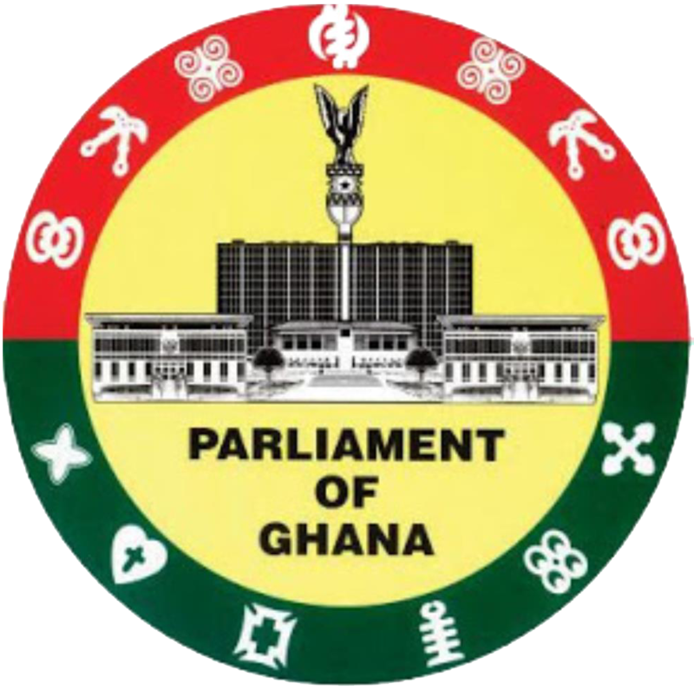

**ADDRESS BY HON. FRANCIS ASENSO-BOAKYE, MP FOR BANTAMA AND CHAIRMAN OF THE KUMASI BLOC OF PARLIAMENT AT THE KUMASI DIALOGUE**

MONDAY, 24TH MARCH, 2025

Colleague Honourable Members of Parliament,

Distinguished Guests,

Revered Chiefs and Religious Leaders,

Members of the Diplomatic and Business Community,

Development Partners,

Members of the Media,

Ladies and Gentlemen,

Partners in Kumasi’s development,

**Good Morning to you all**

1. I welcome you all to this historic gathering—the maiden Kumasi Dialogue, where we come together to assess and shape the impact of the 2025 budget on our great city.

1. For the first time in history, Members of Parliament from Kumasi have come together under one united platform- the Kumasi Bloc- to pursue a development-focused agenda for our city.
2. We are united, not by party colours, but by a shared conviction that Kumasi deserves better – and that its transformation requires deliberate, strategic, and urgent actions.
3. As chairman of the Kumasi bloc of Members of Parliament, I stand before you deeply committed to harnessing our collective resources and expertise to advance our great city.
4. Today, I want to share our vision of a Kumasi that overcomes its longstanding challenges and re-emerges as a beacon of modern urban settlement in Ghana.
5. Before I proceed further, I would like to take a moment to acknowledge the contributions of the former MPs from Kumasi, many of whom have laid the foundation for what we are building today.
6. We stand today on the shoulders of those who came before us, and we are inspired by their sacrifices and commitment to Kumasi’s development.

**Our Challenges: A Call to Urgency**

1. Kumasi is undoubtedly one of Ghana’s most dynamic urban centres, yet it faces critical challenges that hinder its growth and the well-being of its residents.
2. Over the years, we have been grappling with persistent issues such as poor land use planning, crime, unemployment and inefficient waste management practices. Our city has unfortunately become familiar with recurring market fires. Just last Friday, we experienced a devastating fire incident at the Kumasi Central Market, Adum, which sadly destroyed countless properties and shattered the livelihoods of many families who depend on this vibrant economic hub. We deeply share in the plights of our dear ones who have been severely affected.
3. These frequent market fires reveal both the potential and the systemic challenges that must be addressed. These experiences, serve as stark reminders that our urban planning, infrastructure, and enforcement regime must be critically looked at if we are to secure a prosperous future for our historic city, Kumasi.
4. Beyond infrastructure, our urban challenges demand immediate attention. These recurring market fires are proof of the consequences of inadequate planning and weak regulatory enforcement.
5. We have seen firsthand how blocked access routes and poor planning have impeded emergency services, including that of our hardworking firefighters, resulting in the loss of vital properties and livelihoods. These tragedies are avoidable and deeply regrettable, and it is our responsibility to ensure that they never recur.
6. We must advocate for robust urban planning measures that enforce land use regulations, upgrade our waste management systems, and introduce stringent safety standards.
7. The time has come for us to rethink how our urban spaces are organized and managed. This means investing in modern infrastructure that can withstand the challenges of a rapidly growing urban population—investments that will safeguard our markets, homes, and public spaces.

**Infrastructure: The Lifeline of Economic Growth**

1. **Ladies and Gentlemen,** I want to draw particular attention to the critical importance of the dislocation of the Accra-Kumasi Highway. This project, which was commenced by the John Agyekum Kufuor administration, was regrettably abandoned by the Mill/Mahama administration. Thankfully, the outgone Akufo-Addo administration continued and undertook significant works, including the construction of four (4) new bypasses that are at advanced stages of completion.
2. The timely completion of the highway is therefore a necessity for economic growth, easing congestion, boosting trade, and facilitating investment across the country.
3. We therefore call upon the government to prioritize the completion of the Accra-Kumasi Highway in the 2025 budget, as its completion will benefit Kumasi in particular, and Ghana as a whole.

**Economic Opportunities and Social Welfare**

1. Kumasi’s challenges extend into sectors such as healthcare, education, and job creation, which are all critical areas that are of immense benefit to the well-being of our citizens.
2. Our dialogue today must include strategies to address these issues head-on. Economic development is not an end in itself; it is a means to improve social welfare. Every project we undertake, and every policy we implement, must be centered on enhancing the quality of life for our people.
3. We must create an enabling environment where businesses can thrive, jobs are plentiful, and social services are robust. This requires an integrated approach that brings together public and private sector efforts. It requires partnerships that are built on trust, accountability, and a shared vision for the future, devoid of petty partisan interests.
4. The Kumasi Dialogue is our starting point and will be a forum where ideas can merge into actionable plans for a better Kumasi.

**A Vision for Collective Action**

1. The Kumasi bloc of Parliament is united by a single, resolute purpose: to forge a future where we can collectively pool together our resources, including financial, political, and expertise into tangible development and improved quality of life for every resident of Kumasi. Ultimately, our goal is to create a Kumasi that is resilient, safe, and economically vibrant.
2. **Ladies and Gentlemen,** our gathering here is to listen, engage, and extract insights from civil society, business leaders, market associations, drivers, artisans, academia, and, the good people of Kumasi, while we scrutinize the 2025 National Budget in through the lens of Kumasi’s development priorities.
3. As representatives of the people, we will amplify your voices, to ensure that Kumasi attains its perfect share of national development.
4. Our discussions must therefore lead to actionable solutions that can be implemented swiftly to protect, preserve, and preserve our community and propel us towards sustainable growth and development.
5. This dialogue will not just be a talk shop. It is a call to action, and the views expressed here will not be shelved. They will form the basis of a unified parliamentary advocacy by the Kumasi Bloc – to push for what is right, fair, and necessary for the growth of our city, including better road networks and drainage, efficient transport systems, decent jobs, strong healthcare systems, and infrastructure that meets the needs of our growing population.
6. **Ladies and Gentlemen,** I, therefore, encourage everyone here, young and old, big or small, to fully take part in this dialogue, for the benefit of our city, Kumasi.
7. **Good people of Kumasi! Let us arise and build!**
8. **Kumasi-man! Mo mma yɛn sɔre!**
9. **God bless Kumasi, and make us great and strong!**
10. **Once again, I thank you for your attention!**